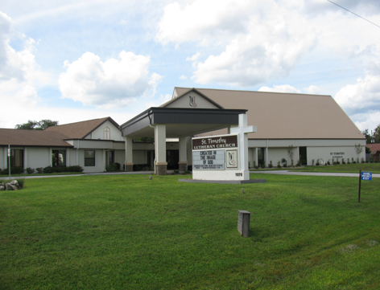
ST. TIMOTHY EVANGELICAL
LUTHERAN CHURCH

Vineyard Views
March 2023

Pastor Joanie's Message
Jesus, keep me near the cross, there's a precious fountain; free to all, a healing stream flows from Calv'ry's mountain.
These are the first lines of a hymn that we often sing in Lent. Does anyone besides me find it hard to stay near the cross in the midst of our busy lives and overloaded schedules? Which is unfortunate since we need the cross most when we are busiest and find our busy schedules keeping us from participating in mid week Lenten meals and spiritual growth opportunities, as well as taking us away from worship opportunities on the weekend. There are demands of household, jobs, family, friends, hobbies, and places to go and things to do. Pastors are not immune to these distractions, but our absences are more noticed and harder to explain - but busy can interfere with our devotional time and time for personal study and reflection - no one notices if we do these very important things.
The fact of the matter is - none of us can stay focused on Christ and near the cross on our own. That is why we cry out, "Jesus, keep me near the cross!" We need Jesus in our lives to help us set our priorities, avoid things that lead us away from His presence and time with Him, and to help us focus on growing in our relationship with Christ and letting Him heal our wounds and soothe our anxieties. God does not just call us into a relationship, but Christ promises to be with us and to send the Holy Spirit to help us make the right choices and serve as our divine counselor.
Our Lenten journey began Ash Wednesday, February 22nd. As we approach the empty tomb and prepare to come face to face with the risen Christ, let us turn to Christ and trust Him to be with us always - everywhere. I pray that God will help each of us live our lives confident in the knowledge that He will help us live near the cross and He will help us reflect His light in a world desperate for this Good News.
Blessed to be Traveling with All of You!
Pastor Joanie

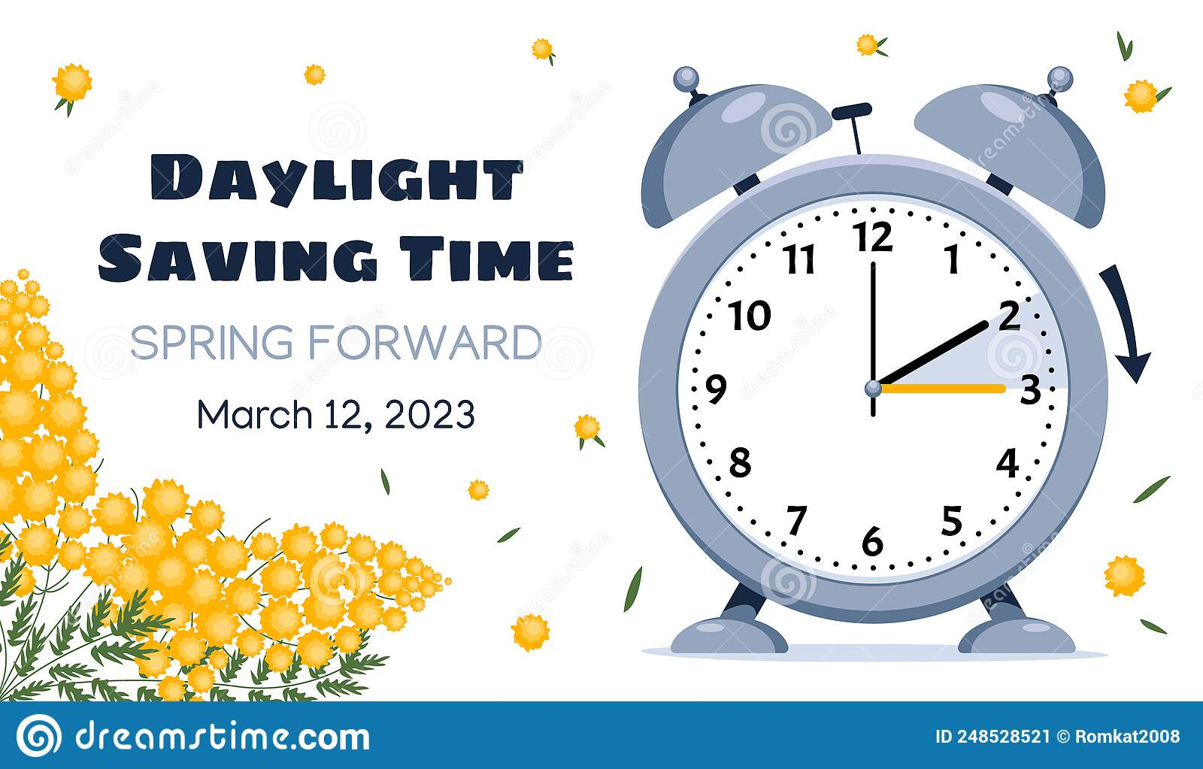
Beginning March 4th, the Saturday service time returns to 5pm.
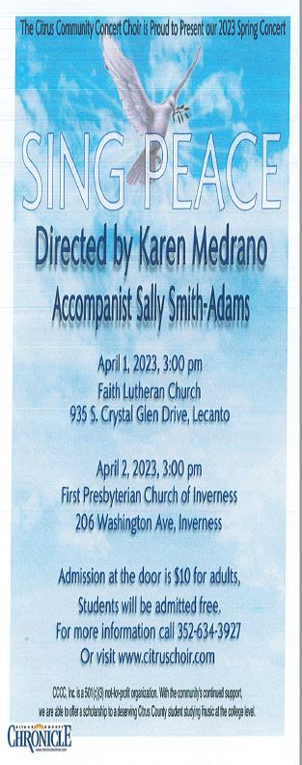

Just a Reminder if You Happen to Be the Last One Out of the Building
If you happen to find yourself the last one leaving the building – please go by one of the Lock-Up Check Lists that are located throughout the building. These are put up to help us to remember to check all the doors, restrooms, and thermostats etc. Thank You for helping us keep our building secure and our power bills down.

Pinch & Praise Plan
At our Healthy Congregations Workshop - we were taught about the benefits of a "Pinch & Praise Box" where people can place their pinches (concerns) - but also their praise thoughts which would be responded to by person or persons (not Pastor Joanie) appointed by the Council. All churches are encouraged to learn about this plan and to use it in our congregations. You will have the opportunity to read about this in the next couple of newsletters and you will also have the opportunity after the New Year to ask questions and share your thoughts about the potential of this activity within the life of the church. So.... please look at the chart and read the material - pray about the possibilities and be ready to engage when the time comes. Thank You!

Pastor Joanie
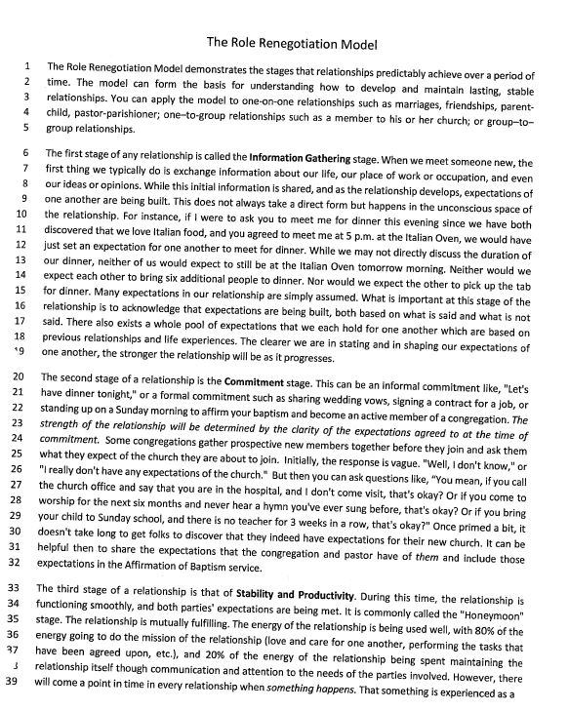
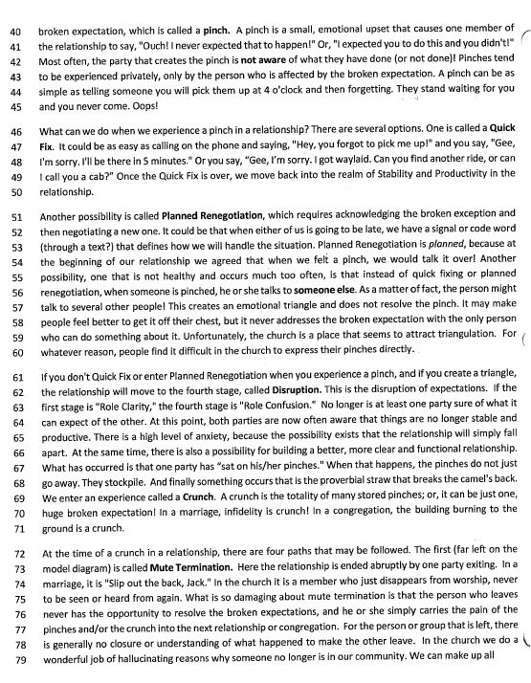
Some Brief – But Important Reminders
“Benevolence” is sent out of the church for things such as Lutheran Services, etc.
BENEVOLENCE GUIDELINES, EFFECTIVE SINCE JANUARY 1, 2021
Effective January 1, 2021, we will send all money given, for any and all benevolences each month, to the designated benevolence for that month. If you wish to give to a benevolence that is not the benevolence for the current month, you will need to send it directly to that benevolence. The Secretary can assist you with addresses of the benevolences. The Council and Treasurers thank you for your cooperation in this.

Here is the List of Monthly Benevolences
If you wish to give to them when they are not the monthly benevolence, please send your contribution directly to the address provided
January Lutheran Services Florida
3627 W. Waters Avenue, Tampa, FL 33614
February Together in Mission – ELCA Outreach Projects Synod
3838 West Cypress Street, Tampa, FL 33607
March E-Nini-Hassee (Outdoor Therapeutic School for girls)
7027 E. Stage Coach Trail, Floral City, FL 34436 ‎
April The Path
21 S. Melbourne Street,
Beverly Hills, FL 34465

May Lifetree Food Pantry
1501 SE US HWY 19, Crystal River, FL 34429
June Habitat for Humanity
Habitat for Humanity International: Citrus County Florida
322 West Lamar Street, Americus, GA 31709-3543
July Florida Disaster Relief
Florida Bahamas Synod, 3838 West Cypress Street,
Tampa, FL 33607
August ELCA Fund for Leaders
ELCA Gift Processing Center, P.O. Box 1806,
Merrifield, VA 22116-8000
September Nature Coast Ministries – Medical and Dental
7655 W. Gulf to Lake Highway, Crystal River, FL 34429
October World Hunger Appeal
Florida Bahamas Synod, 3838 West Cypress Street
Tampa, FL 33607
November Citrus County Blessings
Citrus County Harvest Inc
P.O. Box 82, Lecanto, FL 34461
December Day Star
6751 W. Gulf to Lake Highway
Crystal River, FL 34429
Thank You for helping us be better stewards of our funds and our volunteers’ time.
Pastor Joanie

POWER OF PRAYER AND INSPIRATION
“WE CAN DO IT”
By Barbara Carson

I am sure everyone has heard of “Rosie the Riveter”. This poster during World War II in 1943 symbolized a “ we can do it” and morale booster theme. I am taking it a little further and saying it can be an inspirational image of what we can all do.
This shows us how God shapes us. We are unique and our own design.
Philippians 4:13 says “I can do all things through Christ , because he gives me strength”. Proverbs 16:3 says “Depend on the Lord in whatever you do and your plans will succeed”.
God can bring us back to “youngness” (freshness) as we draw closer to God. Another word I learned was “In-spirited” which can be a spirit of creativity producing things we thought we were not capable of doing. Another phrase is GRIND, GRIT, AND GRACE standing for strength, purpose and inspiration.
You can put these all together and call it “ Synergy” which is uniting to create something greater.
That’s what God can do for you with the power of prayer. Praise the Lord.

2023 Easter Food Box Supply List
Wow! Time sure goes by fast. Seems like we just got done with Thanksgiving Food Boxes and we need to start collecting for Easter Boxes. We will continue to provide 40 food boxes and Easter baskets for their children for families in our community and will begin March 4, 2023. If you would like to request a box for a family member or friend, forms will be available on the table in the fellowship hall and need to be turned in to Patti Cyr (Box #139) no later than March 19th .
Please purchase only these items (CHECK EXPIRATION DATES):
Sugar Canned Fruit
Canned Chicken Canned Vegetables (corn/green beans)
Canned Ham Pasta
Tuna Spaghetti Sauce (preferred – canned)
Soup Instant Potatoes
Peanut Butter White Rice
Jelly Gravy (prefer brown)
Saltine crackers Jello and Pudding
Macaroni & Cheese Canned Chili
Baked Beans (Canned) Kool-Aid (individual packets)
Biscuit or Muffin Mix
Oatmeal (prefer box with individual packets)

Place food in designated bins under the table in the fellowship hall no later than Sunday March 26, 2023. Thanks so very much for the food, funds and help you, so willingly, donate for this activity.

Packing of the food boxes will be March 30, 2023. A light lunch will be at Noon and packing will be done afterwards.

Much thanks and blessing
~Patti Cyr Cell # 352-422-7313. Leave a message and I will return your call.

NEEDED FOR EASTER BUCKETS (for food boxes)
******Buckets (no baskets)
Large Plastic Bags (to put buckets in)
Easter Grass
Plastic Easter Eggs (for buckets and egg hunt)
****Individually wrapped candy for eggs (no chocolate)
Easter Pencils
Easter Erasers
Crayons 16oz, 24ct (large boxes can be divided)
Large Crayons (for 3-4yr olds)
Colored Pencils (for older children)
Coloring/Activity Books (ages 3-10)
Scratch Pads (like those we get in mail)
Small Toys (like McDonald’s fun meal)
Activity Books (for older teens -crosswords, Sudoku, etc.)
Note: Many of the items can be found at Dollar Tree, Big Lots, Dollar General, Ollie’s, etc.)
We will be assembling the buckets at my house on Wednesday, April 6th, so they can be matched with food boxes at church.
Any questions, see me.
Thank you, Kathy Burkett, Box #81
**Note – No stuffed animals. We use our Teddy Bears. We do Easter Buckets for baby-18yrs; plus older, if they have developmental issues.
Any additional buckets, not assigned to food boxes, will be taken to The Path and Daystar.

The Souper Bowl of Caring was a huge success and thanks to all who contributed by bringing in food. Although we didn’t accurately predict the winner, we collected 446 cans total. Our score was NFC-232, AFC-214. It was a very close score for sure. The actual score was 38-35, with the Chiefs (AFC) tomahawking the Eagles (NFC). The actual score was very close with 3 points separating them and it was a very exciting game. The cans were counted on February 12, while I was at Sunday School. Thank you so much, to those who helped Randy count the cans. The cans were then brought to LifeTree Church by Bill Dexter where they were very much appreciated. Thanks again to all who participated.

Sincerely,
Barbara Johnson, “The Coach”

LIVESTREAMING
The new equipment is up and running and we are in need of volunteers willing to be trained. If you are interested, please contact Barbara Johnson or Dick Kleinsmith.

ATTENTION ST TIMOTHY FOLKS!
We need volunteers to take photos at church events. These photos will go into the Vineyard Views and on the bulletin board outside the fellowship hall. You don’t have to be an expert photographer. Photos can be taken with your cell phone and either emailed to the office or stop by and we’ll pull them off your phone for you.

WORLD’S GREATEST BABY SHOWER
We have the fully loaded chests on display for everyone to see what your donations have accomplished.
Again, Thank You for your donations and making our part of the World’s Greatest Baby Shower a success!
Contact Lauri Burns 724-967-3691, box 150

YARD SALE/ FUNDRAISER
The Garden Club of Crystal River will be holding a yard sale at Nancy Schneider’s home at 7227 West Avocado St. in Crystal River on March 10th and 11th from 8am-3pm. All proceeds will go towards a $1,000 scholarship given to a Crystal River High School Senior and a campership scholarship to Wekiva Camp.
“CRAFT FAIR PLUS”
On March 25th, we will be holding a “Craft Fair Plus” at Crystal Oak Civic Center House at 4958 W. Crystal Oaks Drive in Lecanto from 10am-3pm. Funds from this will go to our general fund and to support our Junior Garden Club at Crystal River Primary School.
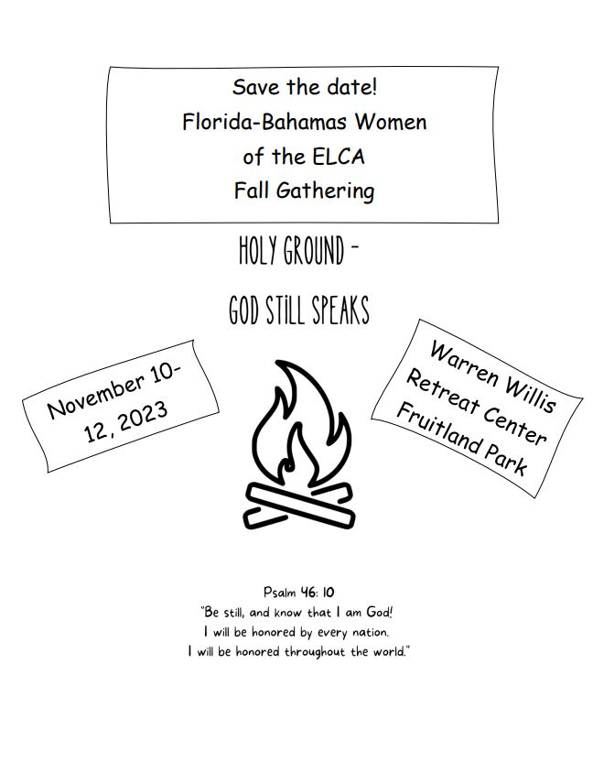

DEADLINES
Please be aware that if you have entries for the weekend worship bulletins/announcements you need to have them in on the Tuesday prior, as we are preparing and printing them no later than Wednesday. If you have submissions for the April 2023 Vineyard Views, please have them in to the office no later than end of day on Thursday, March 23, 2023

MOST
MOST looked at how we could help St. Timothy continue in all the outreach programs that we do. There are many St. Timothy family members that live alone and/or need help with simple things that they cannot do safely anymore. MOST would like to help you, if we can, by doing small jobs for you. Examples: cutting grass, power washing driveways, sidewalks, cleaning up outside garden, bushes, and so on. Call the office with your requests and we will look at each one to decide if MOST can help you make your day a little brighter.
-Deacon Frank

SERVING HANDS
Serving Hands is a new program to help members in our own congregation. Serving Hands is there for you if you need some help in the following areas: a meal brought to you, driving you to an appointment, a friendly visit, doing a household chore, communion brought to you, walking your dog, or picking up food for your pet, etc. These are one-time opportunities, not forever experiences. Please contact Carolyn Fialkowski at 814-392-4281, or Jean Fowler at 586-322-8337 if you need help.
Please don’t hesitate to call. We want to serve you! Also, if you are willing to help with any of these services, there is a sign-up chart on the kiosk in the entrance way of the church or call one of these ladies.

NEW PRAYER GROUP NEWS!!!!!!
OUR NEW PRAYER GROUP MEETS ON THURSDAYS AT 10:00 AT THE CHURCH. As stated before, this new prayer group is open to both men and women and the main focus is on prayer of all types in a private and intimate way. This is not a class or instructional group but Christians coming together to witness the Power of Prayer. I did put up information on the kiosk in the narthex for interested people. If you have any questions contact Barbara Carson. May the Lord direct your path to this inspiring and meaningful way to help ourselves and our congregation.

INFORMATION FROM THE FINANCE COMMITTEE AND YOUR TREASURERS
So far this year we are in a positive mode financially, and we hope to continue this trend barring any unexpected expenses. We are most grateful to our members and friends who support our programs and their commitment to St. Timothy through their prayers, offerings, time and talents.

PROPERTY COMMITTEE
CITY SEWER UPDATE- Ron Roecker will keep us updated when information is available.

THRIVENT FINANCIAL NEWS FOR MARCH 2023

$$$THRIVENT CHOICE DOLLARS®$$$
Thanks so much to our Thrivent Financial members and friends who direct their Thrivent Choice Dollars® to St. Timothy Lutheran Church. When Thrivent Choice Dollars® are deposited into our church account they are available for activities and projects for our mission and ministry here at St. Timothy. If you are an eligible Thrivent Financial member and have Choice Dollars® available, please call Thrivent (800-847-4836) and say “Thrivent Choice®” or go online to www.thrivent.com/thriventchoice and direct your dollars…hopefully to St. Timothy Lutheran Church in Crystal River. For 2023 our church has received $287.00 through this program.
The following members designated their Dollars® to our church in January:
Patti Cyr Lynn Dively Sue Nawrocki
Gwen Pringle Veronica Yellico

****REMINDER: If you have Choice Dollars® remaining for 2022, please designate them by March 31, 2023. Either use them or lose them!

THRIVENT ACTION TEAMS THRI
Thrivent Action Teams make it easy for you to bring people together to make a positive change in your community! When you see a need, apply to lead a volunteer team. Once your idea is approved, a Thrivent Action Kit is delivered to your door. It’s packed with everything you need to help make your project a success. It even includes $250** in seed money to help get your project started. After you finish the project you report the results on-line to Thrivent. This program is brought to you by Thrivent Financial because they believe that being wise with money and living generously go hand in hand. All your questions and requests for this funding program will be answered by going to Thrivent.com/actionteam.****Please note that Thrivent Financial funds accessed for all programs and activities involving St. Timothy Lutheran Church need to be approved by a Committee and the Congregational Council. The following activities have been approved for 2023: Easter Food Boxes and World’s Greatest Baby Shower.

THE $250 IN SEED MONEY IS A GIFT FROM THRIVENT THAT WE CAN USE TO HELP WITH COMMUNITY OUTREACH AND PROJECTS INVOLVING OUR CONGREGATION. THESE FUNDS ARE IN ADDITION TO OUR BUDGETED AMOUNTS AND OFFERINGS AND DONATIONS MADE BY OUR MEMBERS AND FRIENDS.

Our Financial Representatives for answering questions and offering advice on Thrivent investments and products are:
Katherine Gross in Gainesville, FL Rachel E. Sams in Ocala, FL
352-505-8905 352-502-9391
Katherine.gross@thrivent.com Rachel.mangum@thrivent.com

L.W. R.
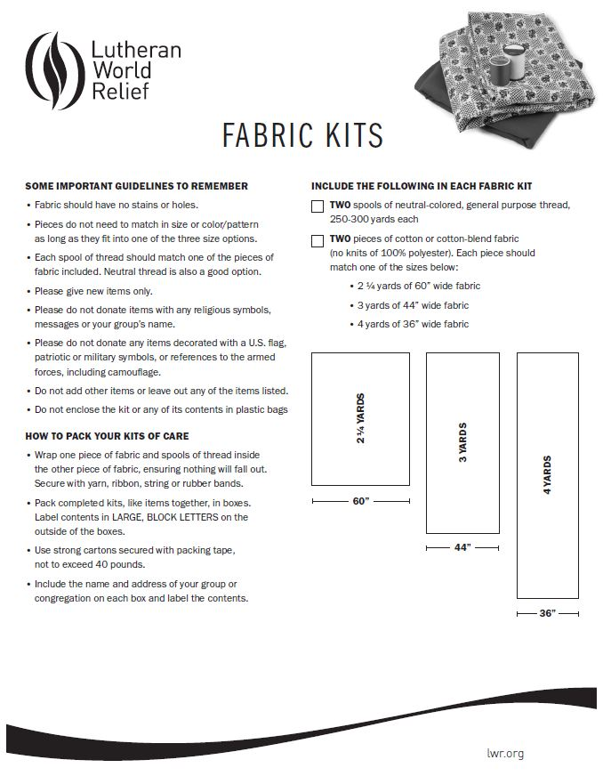
“Kit of the Month”
ST TIMOTHY’S WEBSITE
Here is the St. Timothy website address: https://www.sttimlutherancrystalriver.com/

There are links for the weekend’s services on the homepage. Please note that the links will change every week, since this is a YouTube file address; every service has its own link. Watch for an email with the updated links when they are ready. The video links for previous weekend's will still be available at the bottom of the webpage, as the links are updated each week. Please contact us if you would like a CD of any of the services to listen to. Be sure to check out our children’s artwork at the bottom of the home page. We hope to add more as they send it to us.

Here is a link to Pastor Joanie's YouTube:

https://www.youtube.com/channel/UC5xrMj8-8_6iyR_KxjFAwRQ/videos

Facebook more.
See our Facebook page for information about upcoming events and Please feel free to message us with suggestions about content. - Regina

St. Timothy Evangelical Lutheran Church | Facebook

COFFEE HOUR
We all enjoy getting together after the Sunday Service to visit and share what is going on in each other’s lives. The tasty treats make this time even more enjoyable! The problem is that there are only 3 people that steadily sign up and bring goodies in. And yes, we do have members drop off an occasional treat (and they are good, and we thank you), but we cannot count on that, so we have to make sure every Sunday is covered. Guess who does it then? So PLEASE, PLEASE PLEASE HELP US! Sign up on the kiosk in the entry way for a Sunday to bring treats. Treats do not have to be homemade. Store bought cookies, cakes, sweet breads, coffee cake, or donuts are just fine. You need to supply enough for 35. We have coffee and water, so if you would pick up tea, lemonade, or juice to supplement these, it would be nice. Randy and Carolyn don’t mind making the coffee, plating up your treat, serving and cleaning up. But if you want, you are welcome to do any or all! It’s a great way to serve your fellow brothers and sisters in our church.
- The Hospitality Committee
Sign up! Sign up ! Sign up! Sign up! Sign up!
********************************************************

***CITRUS BLESSINGS UPDATE***
Next packing – Wednesday, March 1st at 10:00am

FOOD PANTRY
Food Pantry- is now operating every 2nd and 4th Tuesday of the month, from 9:30am-Noon. We give out everything at this time. The cupboards are bare. We could basically use everything and anything. Suggestions are essentials which would be- macaroni and cheese, canned meat- tuna and chicken, pasta, Chef Boyardee type pastas, beef stew, chili, canned fruit and canned vegetables. We could also use cat food and dog food.
You can also give monetarily by writing a check out to Life Tree Church or Barbara Johnson and putting food pantry in the memo line. Then put the check in an envelope and put it in my mailbox #210.
Thank you very much for anything and everything you can give us.
Respectfully submitted, Barbara Johnson

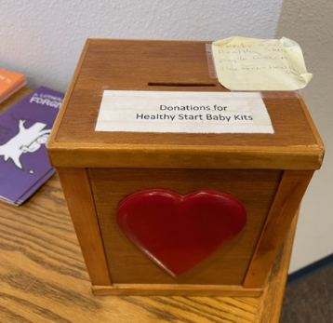
HEALTHY START NEWS
Carolyn Fialkowski is the new leader for Healthy Start outreach. Healthy Start packing will continue to be the first Monday of each month, at the new time 11:00 am.
It costs about $300 a month to do a good job on the Healthy Start bags. These bags are needed and appreciated by the Health Department for new moms in our county- most of whom are seriously in need. Please help as you can by money donations (you can put it in the box on the table with the bulletins), cash or checks, made out to WELCA (put "healthy start" on the memo line), or by buying items on the list. Items currently needed: baby blankets, baby oil, baby shampoo, booties or socks, gentle soap, toy or teething ring, wash cloths. Please remember that in order to provide these bags each month, we need 13 of each item. A complete list can be found on the WELCA board, or you can request it from the office.

The Sunshine Card Makers
The Sunshine Card Makers meet the first Wednesday of each month, in the fellowship hall, at 11:30, at St. Timothy’s. Bring your lunch and join us in creating cards. Plenty of room for social distancing, and you are welcome to bring your own supplies if you wish.

Thank you for the support. -Kathy

Senior Care Resources
Caring.com is a free resource that provides comprehensive information on topics like financial support, and care options to family caregivers seeking information as they care for aging parents by AARP, The Administration for Community Living, The National Legal Resource Center, and Forbes, as well as referenced by many governmental agencies and organizations across the internet.
https://www.caring.com/senior-living/memory-care-facilities/
https://www.caring.com/senior-living/memory-care-facilities/florida
https://www.caring.com/caregivers/alzheimers/
https://www.caring.com/caregivers/dementia/

WE HAVE SEVERAL HANDBOOKS ON DEMENTIA IN THE CHURCH LIBRARY, IF ANYONE WOULD LIKE INFORMATION

!!TWO THINGS ABOUT MAILBOXES!!
CHECK THEM - even if you are not ready to return to worship, please come by during the week and check your mailboxes. We continue to try to keep everyone informed and connected, so we put things in the mailboxes – especially for folks that don’t have email addresses. SOOOO – please check your mailboxes.
PUT MAIL IN CORRECT BOXES - Please make sure you only put mail in boxes that have a name under them. If you have something for people who have left and their name has been removed from the mailbox, please use their postal mailing address.

Medical response :
There is an instruction video on the Philips AED which we have on utube as follows: Youtube.com/watch?v=Zw78XnpjAGU or just go to utube and search. Also there is a short video on utube from the American Heart for “hands only” CPR. We do have first aid kits at church as well. Don’t hesitate to reach out if you need help as there are congregational members that can help you.

Directory Updates
Smith, Leonese
245 Sleepy Hollow Rd.
Fall River, WI 53932

Farewell-Mundy, Nina
ninafarewell@gmail.com

FUN FACTS ABOUT FOLKS OF ST. TIMOTHY

This month, Nina (Farewell) Mundy has written down a few fun facts to share with us.

“I did not know my great great grandmother or my great grandmother. My great great grandmother had an old cookbook that she passed on to my great grandmother, who then passed it on to my grandmother. My grandmother passed it on to my mom; who eventually gave it to me.
I have a New Testament Bible, that belonged to an S.G. Lewis, with the date February 8, 1816, written inside it.
I also have a very old blue necklace.
When I was about three years old we had a horse, named Queenie. One day my mom could not find me. I was out in the barn walking underneath the horse’s belly. She did not even kick me.”
-Nina (Farewell) Mundy

Here are a few pictures from my life
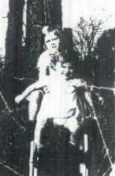
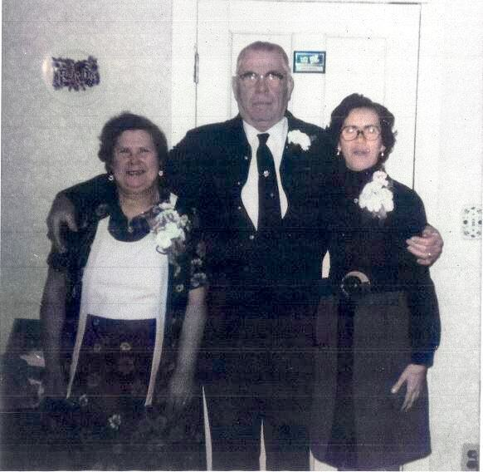

Taken 10/2/1951 in 18 yrs old -Graduation Easter 1983
New York Betty & Stillmon Farewell
Top: me and me
Bottom: Ann Farewell

Chris Liquori 03/04
Brenda Kenney 03/05
Judith Lambert 03/06
Lauri Burns 03/07
Steven York 03/09
Margo Blum 03/09
Amelia Liquori 03/10
Keith Johns 03/11
Willard Cunningham 03/12
Sharon Ricketts 03/13
Jane Estep 03/16
John Kenney 03/18
Nina Mundy 03/22
Leah Haussmann 03/25
Avery Messier 03/26
Bill Fullerton 03/31

Birthday Blessings!

SUNDAY | MONDAY | TUESDAY | WEDNESDAY | THURSDAY | FRIDAY | SATURDAY
 |  |  | 1  10am - Blessings  11:30 Card Makers  4pm – Lent Svc  5pm – Soup Supper | 2  10am -prayer group  11:30 Miniatures | 3  7:30 – Bulletin folders | 4  5pm Worship
5  9am Worship, 9am Children’s SS,  10:30 Adult SS  11-11:30am D-U Communion | 6  11am Healthy Start | 7 | 8  4pm – Lent Svc  5pm – Soup Supper | 9  10am -prayer group  11:30 Miniatures | 10  7:30am Bulletin Folders  8am-3pm  Garden Club Yard Sale | 11  8am-3pm  Garden Club Yard Sale  9am MOST  5pm Worship
12  9am Worship, 9am Children’s SS,  10:30 Adult SS, 11-11:30am D-U Communion, | 13  10:30 RUTH Circle  5pm - Chimes | 14  1pm Garden Club | 15  4pm – Lent Svc  5pm – Soup Supper | 16  10am prayer group  11:30 Miniatures | 17  7:30am Bulletin Folders | 18  5pm Worship
19  9am Worship, 9am Children’s SS, 10:30am Adult SS  11-11:30am D-U Communion, 12- Council | 20 | 21  1pm WELCA | 22  4pm – Lent Svc  5pm – Soup Supper | 23  10am prayer group  11:30 Miniatures | 24  7:30am Bulletin Folders | 25  10am-3pm  Garden Club  “Craft Fair Plus”  5pm Worship
26  9am Worship, 9am Children’s SS, 10:30am Adult SS | 27  5pm - Chimes | 28 | 29  4pm – Lent Svc  5pm – Soup Supper | 30  10am prayer group  11:30 Miniatures | 31  7:30am Bulletin Folders
March 2023

Pastor Joan (Joanie) E. Holden
1070 N. Suncoast Blvd.
Crystal River, FL 34429
Phone: 352-795-5325
Pastor Cell: 850-774-7730
Church cell: 352-422-3769
Fax: 352-795-0468
Email: crsttimothy@tampabay.rr.com Pastor: pastorsttimothy@tampabay.rr.com
Website: www.sttimlutherancrystalriver.com

Deacon: Frank Hofstetter
Music Director:
Church Secretary: Regina Mendicino
Sexton: William “Bill” Dexter

2022 Congregational Council
President: Sarah “Sallie” Haley
Vice-President: Patie Pule
Secretary: Jean Fowler
Treasurers: Lynn Dively & Cheryl VanHorn
Financial Secretary: Randy Holden & Dick Kleinsmith
Council Members: John Seasholtz, Barbara Johnson, Keith Johns, Carolyn Fialkowski, Ron Roecker, Andrea Mitchell, Pastor Joanie, Martie Jarrell, Michelle Roseland, Aidan Sisneros

Weekly Worship
Saturdays 5pm
Sundays 9am
Communion available at both services
Children’s Sunday School, 9am
Adult Sunday School 10:30am
Drive-Up Communion 11-11:30am

Saturday and Sunday Services - links ONLINE

